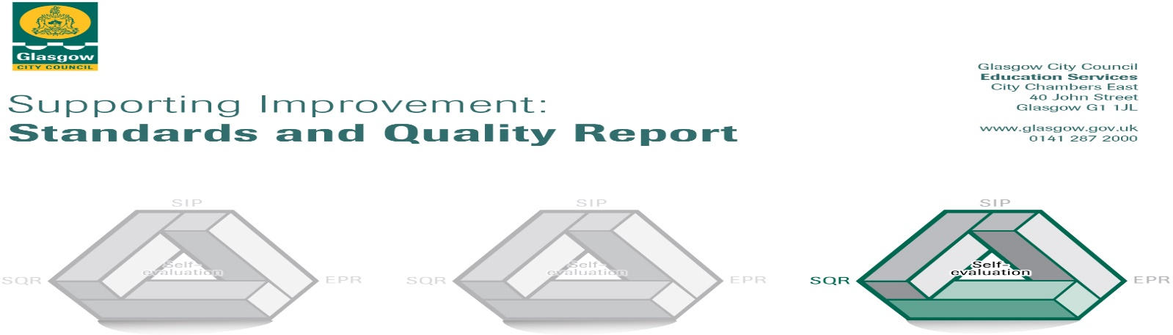
The summary report is provided for parents/careers and partners to outline our achievements this session (2018-2019) and our priorities for next session. Throughout this session we have taken forward our priorities as detailed in our school improvement plan. Through our processes of self-evaluation, we have identified how we can improve outcomes for our children and young people.

Our achievements and improvements this year.
We would like to highlight the following improvements/achievements:
Leadership of Change (1.3)
We have worked together as a community and with external partners to create a shared vision, values and aims of the service in conjunction with relevant documentation, current initiatives, views of the school community and external partners. Continuous self-evaluation enables us to remain focused on areas for improvement. We have worked together to prioritise and improve our outdoor learning education, and have begun pre-PAThS training and child-friendly strategies prior to embarking on the programme in academic year 2019/2020. The management team have worked together on strategies to improve parental involvement in closing the attainment gap.
Staff INSET:
First Aid: Recovery Position.
Seizures: Procedures to follow
Learning for sustainability.
Nurture Principle 5.
Using ICT in reporting procedures.
PAThS: Awareness raising in preparation for implementation.
The Learning Environment
Children’s Interactions.
Children’s Rights.
Developments:
ASL: Staffing and resources to support ASL children’s safety and learning.
Outdoor Learning: Construction/acquisition of a plethora of resources for our outdoors area.
Design and creation of ‘Sand Kitchen’ to enhance outdoors learning.
Continue to develop pilot project with Scottish Government & Inspiring Scotland.
Community Links: Developing relationships with a variety of local businesses/groups (Cruden Building & Renewals Ltd, Stylish Whisky, Tesco, Castlemilk Library, Castlemilk Sports Centre).
Quality Assurance: Development of a robust system of self-evaluation using Q.I’s from a variety of documents (HGIOELC, BtAmb, Care Standards, GIRFEC).
Home/school relations: Development of the promotion of learning at home through parental involvement and training opportunities (to be further developed as specific remit for the TL in conjunction with the LPA).

Learning, Teaching and Assessment (2.3)
S.T.E.M. has been a focus throughout the year for the school community. Visiting TL’s provided INSET training and staff became more confident in the delivery as they observed children’s enthusiasm, skills and enjoyment. Development of the outdoors area has resulted in staff taking learning outdoors which has impacted positively upon children’s wellbeing. Children have opportunities to engage in meaningful, planned teaching activities or to direct their own learning using all areas and resources around them, both indoors and out. Staff are skilled in understanding child development and pedagogy and put this into practice. Staff are skilled in their discussions with children and listen effectively, allowing children to feel respected and involved in their own learning.

Ensuring Wellbeing, Equality and Inclusion (3.1)
All staff recognise the importance of positive wellbeing and have created an environment and provide interactions to promote all aspects of this. We are proactive in promoting positive behaviours and celebrate a wide variety of achievements both from home and in school. Children feel valued in our community, and friendships and equality are promoted to ensure a sense of belonging. The impact of learning outdoors is evident in children’s behaviour, and their general mental health. The Head Teacher is a qualified counsellor and informs staff and parents of techniques as necessary.
All staff are knowledgeable in their statutory duties towards children and parents are aware of our responsibilities regarding this. Staff have recently had training in children’s rights which has promoted informed discussions regarding our role. We actively promote equality and inclusion to ensure all children are valued. Diversity is valued and celebrated. Personal Learning Plans are created where necessary to ensure children’s additional needs are being addressed. Staff work very effectively with children requiring additional long/short term support or enhanced transition, and are included in every activity and outing.

Securing Children’s Progress (3.2)
LPA had lead role in new remit, working with identified children and utilising staff’s knowledge of them to assess and track development. All staff had INSET with LPA regarding the new role and remit and how their work and knowledge informs the aim of closing the attainment gap. LPA met with parents to inform them of the new role and how they can support specific aspects of language development at home. Most children are making very good progress across the curriculum, with remaining children identified for additional support. Some children are requiring challenge across areas and this is being provided by identified staff as well as their keyworker. They are becoming increasingly confident, resilient independent learners as they access all areas and environments, supported by staff to a greater or lesser extent.
We celebrate all achievements which are achieved at home, in school or in the wider community. Children feel valued through this and are motivated to continue improving. Positive reinforcement of achievements, behaviours, interactions etc are a daily part of our nurturing strategy. We actively promote equality for all children throughout our school and through all activities. We are proactive in identifying and reducing barriers to learning to ensure all children feel included and valued.

Here is what we plan to improve next year.
1: Promoting Positive Behaviour through PAThS and reviewing associated school policies; Behaviour Management, Nurture, Health & Wellbeing, Promoting Positive Behaviour.

2: Developing our outdoors learning area to include opportunities for gardening.

3: Digital Learning across the school community.

How can you find out more information about our school?
Please contact us directly if you require further information or if you wish to comment on the report.

The contact e-mail address is: hedteacher@machrie-nursery.glasgow.sch.uk

Our telephone number is: 0141 631 2255

Our school address is: 30 Castlemilk Drive, Glasgow, G45 9TR

Further information is available in: newsletters, the school website, and the school handbook

