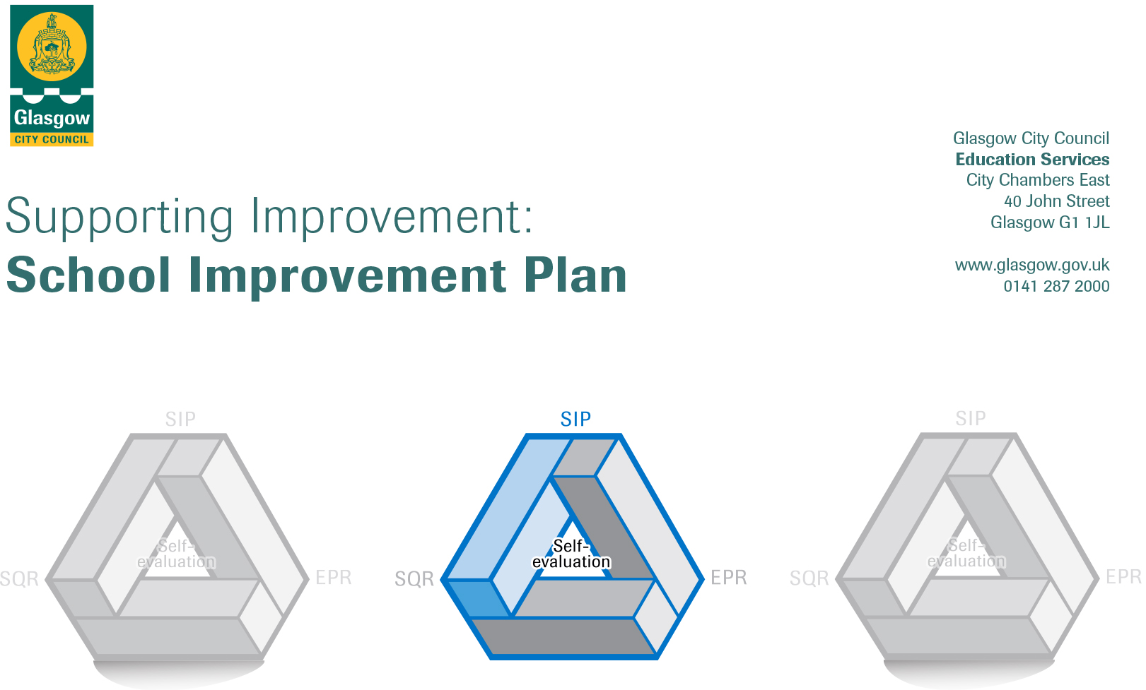2019-2020

Session: 2019-20

Establishment |  | Machrie Nursery School
Head of Establishment |  | Angela O’Hear Hodos
Area/Local Improvement Group |  | South/LIG 3
Head of Service |  | Donnie McLeod
Area Education Officer/  Quality Improvement Officer |  | Claire Harvey

CONTENTS
1. Vision, Values and Aims
2. Summary of Self-Evaluation Process / Priorities for Improvement in the current session
3. Action Planning

Action Plan Summary for Stakeholders

1. Our Vision, Values and Aims

In Machrie Nursery School we aim to provide a welcoming, inclusive and secure learning environment where every child can develop into happy, healthy and self-assured individuals in a climate of mutual respect. We are committed to supporting staff and parents/carers in the development of their skills, thereby enhancing our school and community.

Our Vision and Values

Motivated – Provide exciting, dynamic activities to motivate children.

Achieving – Strive to ensure that children are achieving at their highest level.

Curriculum for Excellence – Deliver high quality teaching and learning experiences using the national curriculum.

Holistic – Promote the child as a whole to encourage nurturing growth.

Relationships – Work in partnership with children and families to foster positive partnerships.

Inclusion – Strive to ensure equal opportunities for all.

Enjoyment – Provide joyful learning experiences which promote wellbeing and imaginative play.

2. Summary of our self-evaluation process.
- Systematic rota of Q.I.’s from HGIOELC, National Care Standards, How Nurturing is our School, Five to Thrive and Care Inspectorate.
- Areas of good practice identified and included in EAP and SQR.
- Areas for improvement identified and considered for following years’ SIP.
- Central theme is identified and appropriate Q.I.’s from the above documentation will be chosen by the staff team and monitored by the Team Leader/ Head Teacher.

Strengths identified:
New planning/assessment/tracking/moderating/reporting systems are being successfully trialled.
Staff more confident in using documentation and identifying areas of success/for development through discussion.
Staff more confident and motivated in S.T.E.M. subjects following a thematic study February 2019.
Outdoors learning has been successfully developed, new projects identified and funding successfully sought for forthcoming year.
Parent/carers and children’s views are sought to identify areas of success and those which require development.
‘Nurturing Groups’ successful in preparation for forthcoming introduction to PAThS.
Staff confidence is developing in leading areas of learning (ECO, Literacy, Enterprise, Citizenship).

Priorities for development:
1: Promoting Positive Behaviour through PAThS and reviewing associated school policies; Behaviour Management, Nurture, Health & Wellbeing, Promoting Positive Behaviour.

2: Developing our outdoors learning area to include opportunities for gardening.

3: Digital Learning across the school community.

No. | Quality Indicator | Priority
1 | 3.1  1.1 | Promoting Positive Behaviour through PAThS).  Reviewing associated school policies (Behaviour Management, Nurture, Health &Wellbeing, Promoting Positive Behaviour)

Tasks to achieve priority | Timescale  and checkpoints | Evidence of Impact > (data, observation, views)
Complete ‘readiness questionnaires’ with staff’ | 30th August. | All staff to indicate their training achievements and needs prior to embarking upon the PAThS calendar of training.
EYLOL to meet with HT and PAThS lead re implementation. | 26th September. | Programme of implementation, review of resources, environment etc in preparation to begin.
Consent letter to parents. | 10th October. | HT to meet with parents/distribute information re PAThS and encourage parental consent.
Review of accompanying policies with staff. | 11th October. | All relevant policies reviewed and amended as required.
Complete children’s PRE evaluations and Coding sheet. | 11th October. | All children with consent to have completed evaluations.
INSET and demonstration lesson. | 11th October | All staff trained as PAThS practitioners, 1 to be lead.
Parent’s information session. | 6th November | Parents able to understand, support and continue PAThS strategies at home.
Begin lessons 1-19 | 22nd Oct – 13th May | Continual review should show progression and benefits of emotional literacy.
EYLOL to observe staff’s delivery and support completion of POST evaluations. | 13th May | POST evaluations to evidence impact.
Parental evaluation | 20th May | Parental views to add to school’s evidence to create holistic evaluation.
Complete children’s POST evaluations. | 4TH June. | EYLOL to collect all POST evaluations to add to overall research-based evidence.

Staff leading on this priority – including partners | Resources and staff development
Head Teacher.  PAThS staff lead  EYLOL | School policies.  PAThS training manual.  PAThS INSET  Visit to PAThS practitioner in neighbouring establishment.

No. | Quality Indicator | Priority
2 | 2.2  2.3  2.7 | Develop an outdoors learning area to include opportunities for gardening.

Tasks to achieve priority | Timescale  and  checkpoints | Evidence of Impact > (data, observation, views)
Staff and children to review current outdoors area. | August.  September. | Data gathered from observations, conversations, questionnaires and Care Inspectorate (May 2019) to inform effectiveness and areas for possible development.
Head Teacher to source resources as detailed in grant awarded by ‘Tesco Bags of Help’ application. | August  September. | Children experience wider range of learning activities.
All staff to be trained in ‘straw bale gardening’. | August.  September. | Children to be growing a variety of vegetables in straw bales which can be harvested later for cooking activities.
Staff and children to decide where new outdoors equipment to be placed for maximum effect. | September | Children motivated to use new equipment in addition to established resources and the impact evidenced in Outdoors Learning Big Book.
Parents to be invited to see our developing garden and learn from their children the art of ‘straw bale gardening’. | April | Children to be confident in outdoor play and growing their produce. Parents to be more confident in playing outdoors with their children and in gardening.
Staff to plan outdoors activities alongside indoors ones and children to have the opportunity to choose outdoors at any time (GCC to assist with environmental alterations). | September.  June. | All planning to show outdoors activities. Environment to accommodate free-flow indoors/outdoors entry and egress.
Management to ensure outdoors learning is embedded throughout all planning. | September.  June. | Planning evidences range of activities offered to children. HT & TL monitoring ensures quality of learning.
Staff and children to review outdoors learning area. | May  June | Data gathered from observations, conversations, questionnaires to inform effectiveness and areas for possible development.

Staff leading on this priority – including partners | Resources and staff development
Head Teacher  Team Leader | ‘Tesco Bags of Help’ grant.  Gardening blogs.  TL monitoring forms.

No. | Quality Indicator | Priority
3 | 1.3  2.2  2.5  3.3 | Developing a Digitally Connected school

Tasks to achieve priority | Timescale  and checkpoints | Evidence of Impact > (data, observation, views)
INSET on digital appliances and Connected Learning. | October. | Staff confident in how to incorporate digital appliances into planning and in their execution of activities.
Delivery of iPads. | November. | Staff and children to have opportunity to freely use the devices to build confidence.
Specific INSET on using age/stage appropriate programmes for young children. | January. | Staff to incorporate digital learning into planned activities.
Designate lead staff member as DLOL. | January. | DLOL to attend all INSET and disseminate info to colleagues and parents.
DLOL to deliver parental INSET re iPads in an educational context and how to promote this at home. | February. | Parents more confident in using digital technology at home with their children.
Review policy, procedures and implementation of ‘Connected Learning’. | March. | Evaluate impact to date and plan for next session, including further INSET or additional resources.

Staff leading on this priority – including partners | Resources and staff development
Head Teacher.  DLOL | INSET Connected Learning.  iPads.

No. | Quality Indicator | Priority

Tasks to achieve priority | Timescale  and checkpoints | Evidence of Impact > (data, observation, views)

Staff leading on this priority – including partners | Resources and staff development

