TOOTHBRUSHING PROGRAMME;
CHILDSMILE

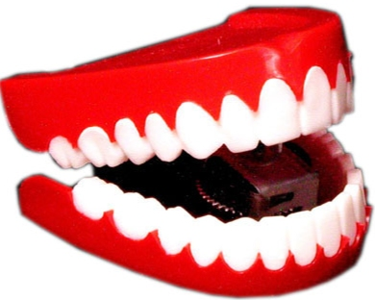

Machrie Nursery School

2017

INDEX PAGE
Rationale 2

Aims 2

Objectives 2

APPENDIX I (PROCEDURES)

1.
Quality Indicator; 3.1

Care Standard; 1

RATIONALE
To improve the quality of tooth care and dental hygiene in general through promotion of a recognised care programme, from which parents and children can benefit.

AIMS
- For children to benefit from a structured, professionally supported dental care programme, conducted by trained Nursery staff.
- For parents to benefit through input from professional dental nurses who promote dental hygiene throughout educational establishments.
- For staff to promote dental hygiene at all times with children, regardless of whether their parents have agreed to participate in the programme or not.
- For the Nursery to promote dental hygiene to parents throughout the year, encouraging them to visit their dentist, attend free courses delivered by dental nurses in the Nursery, and to promote ‘National Smile Month’.

OBJECTIVES
- Appropriate resources to be available to support the programme; toothbrushes/ toothpaste/ brush bus/ napkins/ timers/ gloves/ cleaning brush/ detergent.
- ‘Snack’ area CDO to distribute the equipment on a daily basis.
- Key workers to work with their own group to incorporate the 2minutes of brushing.
- Key worker to wipe the brush bus with a damp napkin following usage.
- Designated CDO’s to hygienically clean and sterilise the brush bus and replenish equipment as required (checked weekly as part of cleaning schedule).
- All equipment to be stored in the Laundry.

Drafted Aug ’17 Mrs Hodos

Reviewed Aug ‘19 Mrs Hodos
_____ ____________________
_____ ____________________
_____ ____________________
_____ ____________________

2.
APPENDIX I

Toothbrushing procedures

Distribution of toothbrushing resources
‘Snack’ staff member to distribute the resources to each core group.

Preparation of toothbrushes
Children to brush teeth every morning and afternoon.
Protective gloves to be worn by staff.
Staff to encourage children to count how many blobs of toothpaste are required to be squeezed on a paper towel (staff member to scoop blob onto toothbrush before giving to child).
Designated staff members to prepare toothbrushes with ‘Sharpie’ pens and place in named space in storage train. (am & pm if a FT placement).

Dry brushing method
Children to brush teeth using dry brush method to ensure teeth are coated with toothpaste containing fluoride.
Toothbrush should be returned to staff member who will rinse brush in running water before returning it to the storage train.
Children should wipe their mouth using a paper towel.
Used paper towels to be put into the bin.

Weekly cleaning of toothbrushing resources.
Toothbrushes to be removed each Monday by designated staff member and placed on a paper towel, ensuring they are not touching each other.
Storage train to be wiped clean with detergent.
Toothbrushes to be rinsed in hot running water, shaken and returned to storage train.
Storage train to be returned to appropriate group drawers.

All storage drawers to be returned to the laundry by core group staff unless Team Leader directs others to do so.

If a child has a cold sore or any mouth infection, toothbrushing should be suspended until the infection has completely cleared up. The child’s toothbrush should be changed for when brushing resumes.

Toothbrushes should be changed termly for each child or earlier if showing signs of wear.

