SNACK

Machrie Nursery School

2017

INDEX PAGE
Rationale 2

Aims 2

Objectives 2

APPENDIX I (Example of snack options)
APPENDIX II (Snack Questionnaire)

1.
Quality Indicator; 2.2

Care Standard; 3

RATIONALE
All children will have access to water throughout the day, and will be offered full-fat milk in accordance with GCC policy which follows appropriate nutritional advice. Each child will be offered a nutritious snack in sociable, pleasant surroundings, choosing from a variety of options.

AIMS
- Parents to be informed of the availability of water and milk for all children.
- Parents to be informed and encouraged to pay the daily charge of 26p per child for ‘snack’ as outlined by Early Years Charging, GCC.
- Children to experience a comfortable, relaxed period where there is opportunity for language development and interaction with their peer group and adults.
- Children to be offered water, milk, carbohydrates and fruit as supplied by CORDIA services in accordance with nutritional guidelines.
- Children to learn social graces and table manners as they choose food, consume, and dispense of any waste. They should behave accordingly and be mannerly to the serving adults at all times.

OBJECTIVES
- Children to wash their hands before choosing snack.
- The snack area to be cleaned with Dettox (or equivalent) before use.
- ‘Snack’ staff member to follow good hygiene practice and wear apron & gloves at all times (blue waterproof dressing to be worn if necessary).
- CORDIA staff to deliver trolley to ‘Snack Area’.
- Staff member in ‘Snack Area’ to ensure there are sufficient provisions for the children, gloves & apron for themselves, and plates & cutlery for each child.
- Children to choose their photo-card and place on the ‘finished’ board.
- Staff to help children to settle at the table.
- Staff to discuss the day’s choices (APP I) and help them to choose, which staff will then distribute to each child to be placed on their plate.
- Staff to encourage children to discuss their choices with one another and develop language of how/where food is grown etc.
- Patterns regarding lack of manners, refusal, lack of appetite or difficulty in choosing should be reported to the Team Leader who will discuss this with parents.
- Staff should assist pupils in clearing their plates and table, and in placing used milk cartons in a basin to be taken to the laundry.
- All snack areas to be cleaned with Dettox (or equivalent) after use.
- Excess yoghurts and cheese-spread to be stored in children’s fridge in kitchen.
- CORDIA staff to remove trolleys to their kitchen for clearance.
- Children to wash hands before resuming activities.
- All cloths used for cleaning to be soaked in detergent overnight and disposed of when deemed necessary.
- Children to complete a yearly questionnaire regarding snack to determine their views and how they feel it could be realistically improved. (APP II)

2.

Drafted January ’17 Mrs Hodos

Reviewed March ‘19 Mrs Hodos
_____ ____________________
_____ ____________________
_____ ____________________
_____ ____________________

3.
APPENDIX I

Cheese sandwich
Ham sandwich
Tuna sandwich
Cheese roll
Banana roll
Pitta bread

Pancakes
Crumpet
Fruit scones
Cheese scones
Plain scones
Oatcakes
Banana loaf
Fairy cake

Fromage frais
Soft cheese
Cheddar cheese

Apples
Bananas
Tangerines
Kiwi fruit
Cherry tomatoes
Melon
Halved grapes

Milk and water are served with snack.

Water is available throughout the day.

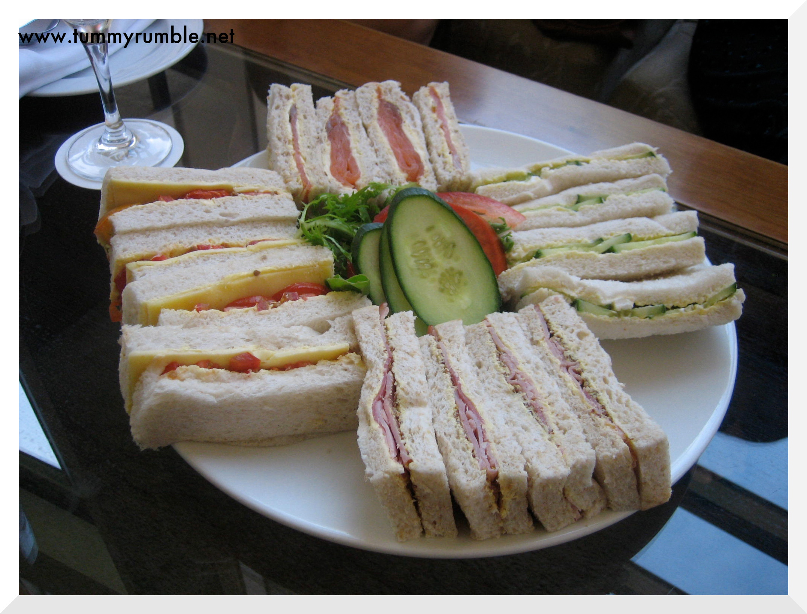
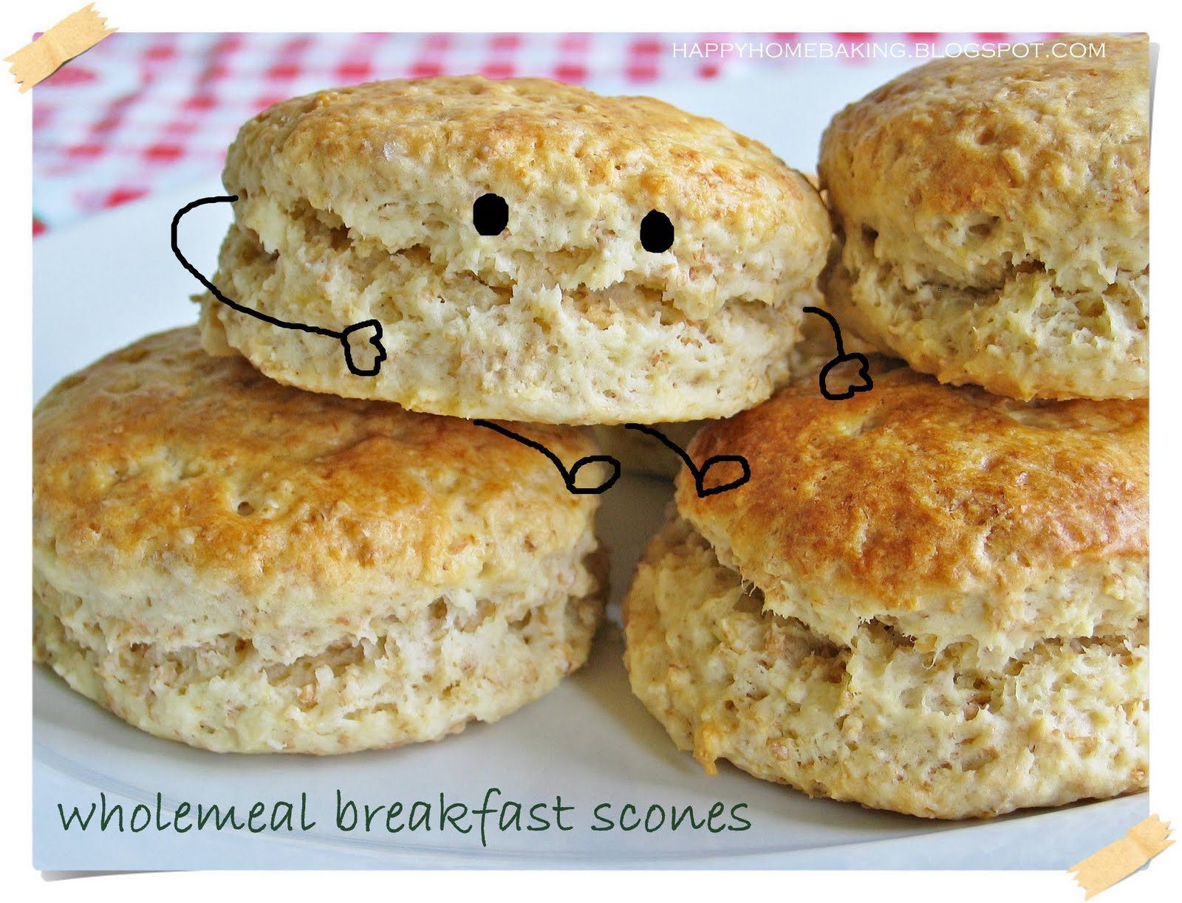
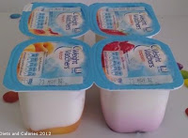

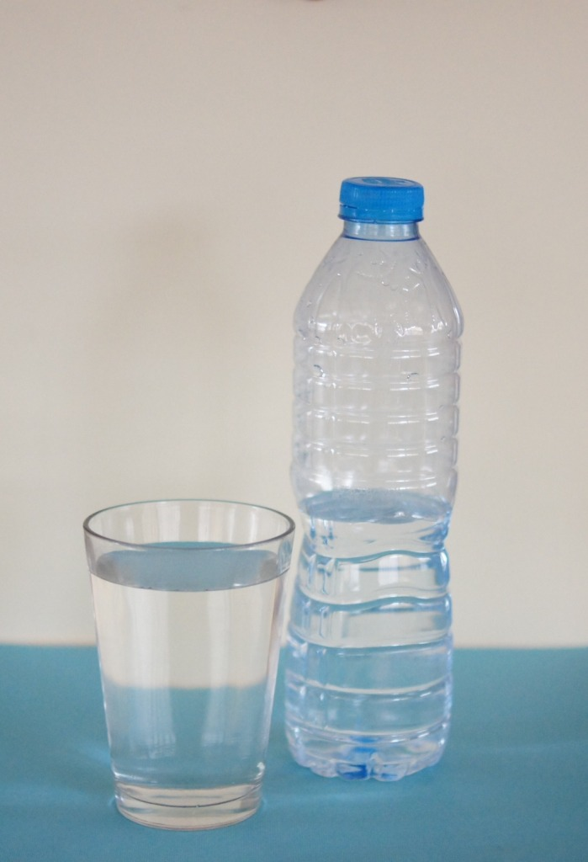

APPENDIX II

Machrie Nursery School
Children’s Questionnaire

Child’s name _____________________________
Date _____________

- Do you always choose ‘snack’ in Machrie Nursery School?
No OK Yes
☹ 😐 ☺

- What do you like about ‘snack’?
____________________________________________________________________________________________________________________________________________________________

3. Do you have any special friends at ‘snack’ time?
No OK Yes
☹ 😐 ☺

- What is your favourite thing to eat for ‘snack’?
____________________________________________________________________________________________________________________________________________________________

5. What do you not like to choose for ‘snack’?
____________________________________________________________________________________________________________________________________________________________

6. How do you think we can improve our ‘snack?
____________________________________________________________________________________________________________________________________________________________

