ASSESSMENT & MODERATION

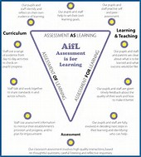

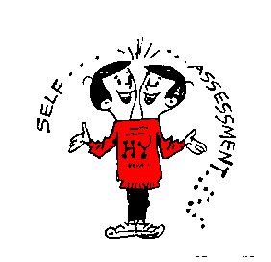

Machrie Nursery School

2017
INDEX PAGE
Rationale 2

Aims 2

Objectives 2

APPENDIX I (‘Profiles’ guidance)

1.
Quality Indicator; 2.3

Care Standard; 3

RATIONALE
To observe children formally and informally in order to gain meaningful and accurate evidence of their progress and attainment, sharing this information with colleagues in order to ensure a level of agreed attainment for the three ‘traffic lights’ attainment of ‘developing’, ‘consolidating’ and ‘confident/secure’. The overall ‘profile’ for each child (containing assessment information and evidence of their work) will be compiled in conjunction with the child and be accessible for parents/carers at all times.

AIMS
- To assess/observe children whilst they are involved in a variety of tasks, structured and unstructured.
- To develop learning conversation with colleagues (from own establishment & NLC) around grading work to be at the various levels of the ‘traffic lights’ system.
- To record levels of concentration, difficulty of task, ability to work alone or in a team, individual needs, next steps, particular areas of interest or disinterest.
- To decide which levels of the ‘traffic lights’ system the children are currently achieving.
- To use this information to assist planning in developing their next steps.
- To summarise for overall tracking and assessment.
- To compile a ‘profile’ of the individual children’s learning journey’s which will be completed in conjunction with them and be accessible for parents/carers.

OBJECTIVES
- For the activity/observation to be detailed on the daily/weekly timetable and further detailed in the child’s assessment profile and/or tracking files.
- Children to be assessed as ‘secure/consolidating/developing.’
- Particular note taken of those children who are either needing further support or challenge,
- Staff to share findings with colleagues at departmental meetings.
- Team Leader/Head Teacher to summarise individual children’s tracking 3 times per year.
- ‘Learning Conversations’ to be completed regularly for each child and held in ‘profile’.
- ‘Ready for School’ checklist to be completed prior to Parent’s meeting May of final year (or before by parental request).
- Children to have ownership of their learning journey ‘profile’.
- Parent/carers to have access to and contribute to the ‘profile’.
- Planning for themes to take account of children’s needs etc, learned from assessment/observation and then decided by the ‘planning committee’ for the month.
2.
Drafted Aug ’17 Mrs Hodos

Reviewed Aug ’19 Mrs Hodos
_____ __________________
_____ __________________
_____ __________________
_____ __________________

APPENDIX I

PLAYROOM 1
Children’s Profiles

NOT photo album.
NOT examples of every Experience & Outcome.
IS evidence of child’s learning journey.

- Child and staff member discuss which work to include which shows progression.
- Evidence (photo/ quote from child or witness/ actual piece of work/ photocopied piece of work).
- Appropriate Experience and Outcome.
- Description of activity/scenario.
- Skills involved.
- Achievements/recognitions to be included e.g. Machrie Star, Mentoring, ‘PAThS’ Child of the Week’…
- Child’s comments/opinions (using post-it notes etc) on snack/ lunch/ Nursery experiences…
- Comments regarding the file itself from child/ parent/ staff member/ student/ visitor…
- Aims and next steps.
- Child to access profiles at all times.
- Parents to access profiles at all times.

Only actual pieces of work to be in poly-pockets, all other pages to be punched and filed.

‘Individual Assessment’ to be filed; tracking, checklists…

Photocopied written reports (6wks, Anti-pre,) to be filed.

‘Profiles’ to be shown to parents at formal meetings (parents to sign and date sheet), and upon request.

