AIMS OF THE SERVICE

Machrie Nursery School

2017
INDEX PAGE
Rationale 2

Aims 2

Objectives 2

APPENDIX I (Care Standards)
APPENDIX II (How Good is Our Early Learning and Childcare?)
APPENDIX III (Mission Statement)

1.
Quality Indicator; 3.2

Care Standard; ALL

Rationale
We strive to provide a welcoming and secure learning environment where children can develop into happy, healthy and self-assured individuals in a climate of mutual respect, and who contribute fully to the community. We aim to present an environment where children can develop into confident, successful learners who can contribute effectively and responsibly to the wider community. We are committed to supporting staff and parents in the development of their skills, enhancing out Nursery performance and the local area.

Aims
- To work in partnership with parents/carers.
- To provide an holistic educational experience for 3-5yrs through Curriculum for Excellence.
- To ensure all stakeholders are welcomed into premises which are safe and fit for purpose.

Objectives
- To ensure all ‘Care Standards’ are being adhered to (APP I).
- To ensure all ‘How Good is Our Early Learning and Childcare’ Quality Indicators are being implemented (APP II).
- To ensure all Glasgow City Council Health & Safety requirements are being met.
- To continually self-evaluate as professionals.
- To include all stake-holders in self-evaluation.
- To ensure all record-keeping, risk assessments and policies are in place, relevant and up-to-date.
- To ensure all staff are appropriately disclosed and qualified to fulfil their remits.
- To provide and display a ‘Mission Statement’ which is accessible for all stakeholders. (APP III).

Drafted August ’17 Mrs Hodos

Reviewed August 2019 Mrs Hodos
_____ ________________
_____ ________________
_____ ________________
_____ ________________

2.
APPENDIX III

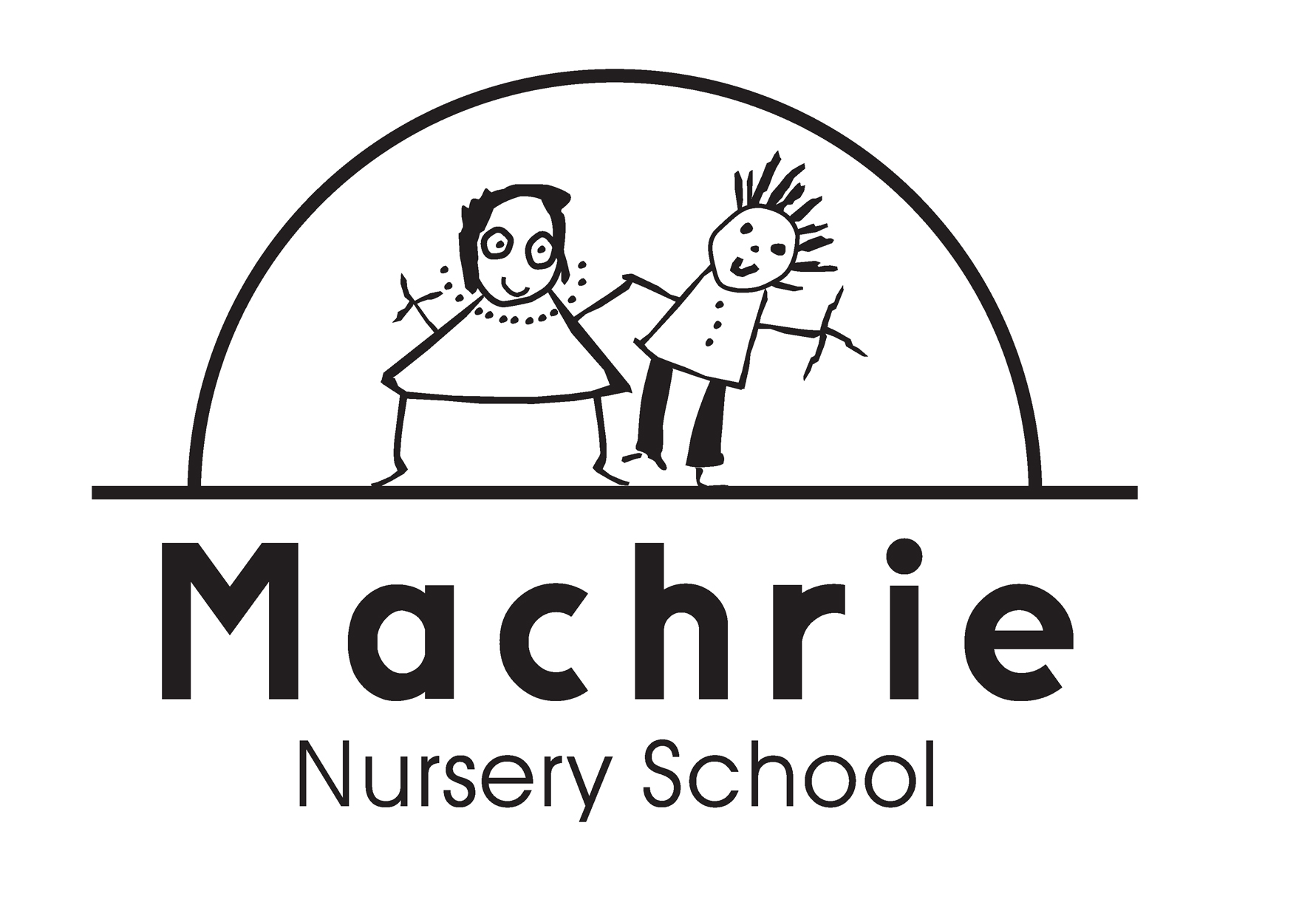

Our Aim
In Machrie Nursery School we aim to provide a welcoming, inclusive and secure learning environment where every child can develop into happy, healthy and self-assured individuals in a climate of mutual respect. We are committed to supporting staff and parents/carers in the development of their skills, thereby enhancing our school and community.

Our Vision and Values
Motivated – Provide exciting, dynamic activities to motivate children.
Achieving – Strive to ensure that children are achieving at their highest level.
Curriculum for Excellence – Deliver high quality teaching and learning experiences using the national curriculum.
Holistic – Promote the child as a whole to encourage personal growth.
Relationships – Work in partnership with children and families to foster positive relations.
Inclusion – Strive to ensure equal opportunities for all.
Enjoyment – Provide joyful learning experiences which promote wellbeing and imaginative play.

